1. Introduction, which describes what your project is, what you are going to achieve. Your hardware and software platforms, sensors used, etc.  
  
2. Project design, provides your design including your interface circuit with sensor/actuator, circuit diagram, and your software design including your algorithm for sensing and actuating of the project tasks.  
  
3. Implementation, language used, any software package or library used, etc. Does your project works correctly for each item as defined in our project assignment? Provide a brief analysis of your system. Provide a few snapshots to show your device at work.  
  
4. Experience and lessons learned, what difficulties you run into in your project? how do you solve them? Any problems are resolved yet? what tricks you discovered that works well for your device kit?  
  
5. A short video demo is required for each project.

**Project 1 Report**

Name: Zoe Yang, Riya Shrestha

1. **Introduction**
2. **Project design**

* Step 1:

We start by setting up a simple circuit with a 220 ohms resistor and a led connecting in series and program it to blink once a second.

* Step 2:

Button 2

Button 1

R3

R2

R1

Led 1

Led 2

This is the circuit diagram for our step 2. Generally, there are two modes: frequency mode and brightness mode.

As it is described, in frequency mode, led 1 will initially blink once 1 second for 3 seconds, and then it will blink 0.25s faster every 3 blinks. A for loop is used to loop through 4 frequency levels (1s, 0.75s, 0.5s, 0.25s) and when reaching the highest frequency, it will go back to 1 blink/second and continue increasing frequency. When button 1 is pressed, led 1 will stop increasing frequency and stay at the current frequency until button 1 is pressed again.

Button 2 is set for switching the mode. When button 2 is pressed, it will switch to brightness mode, which led 2 will start to blink and led 1 is off. There are two levels of brightness (bright and dim). Led 2 is initially set as bright, and when button 1 is pressed, it will turn dim, and when pressed again it will turn bright. Basically, two resistors (R2 & R3) are connected in series. R2 is connected to GPIO 4, as shown in the diagram, and R3 connecting in series with R2 is on the other side connecting to GPIO 3. So when GPIO 4 is power on an GPIO 3 is off, Led 2 is only connected with one 470 ohms resistors, so it will be bright; when GPIO 3 is on and GPIO 4 is off, Led 2 is connected with two resistors (together 1k + 470 = 1470 ohms), so it will be dim.

* Step 3

This is the circuit diagram for step 3. First, we need enable 1-wire in Raspberry pi configuration. …

1. **Implementation**

Part 2:

Part 3:

**…**

1. **Experiences**

**…**

One thing that we have learnt from this project is that we need to start earlier. Because of taking the class and collabrating with group member remotely, we need to prepare our equipments by ourselves and would meet unexpected issues from time to time. Starting earlier will allow us more time to take care of these problems.

…

1. 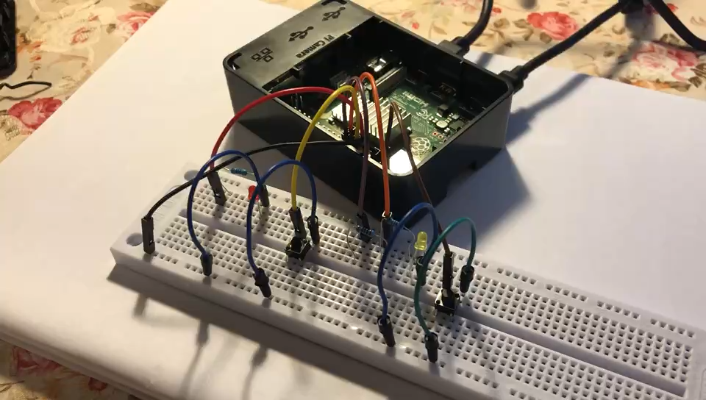**Video demo**

Demo for Step 2 (double click the image):